**Android Final Project Proposal: Budget App**

Group Members: Kayla Boyer, Matthew Drewitt

Summary:

The purpose of this app is to track a monthly budget as well as the spending that occurs during that month. The user can define categories of spending, such as food, rent, gas, and keep a history of purchases under those categories. Purchases that become inventory in the home, such as food, and bathroom essentials, can be added to a home inventory. The user can enter/scan a product they purchased, store information about the item such as name, price, and budget category, which will deduct money from that part of the budget to show how much remains for each expense. The user can also update this inventory with how much remains of each product, and if it is specified as a regular purchase it will be added to a shopping list to make shopping easier.

Functional Requirements:

* MySQL back-end storage
* Zebra Crossing barcode scanner
* Forms to gather user information

Hardware Requirements:

* No special requirements
* Barcode scanner will require a camera on the device, but manual input is available

**Images:**Main Activity:

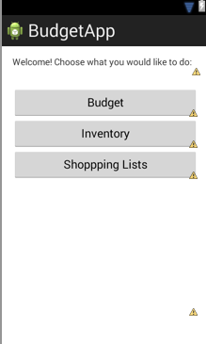

Budget Activity:

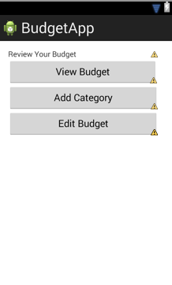

Add Activity:

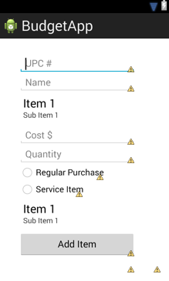

Add Category Activity:

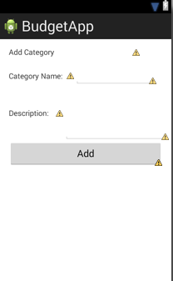

Update Activity:

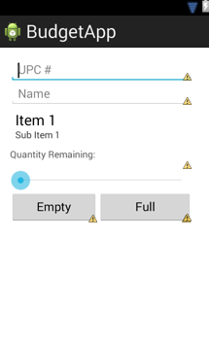

Inventory Activity:

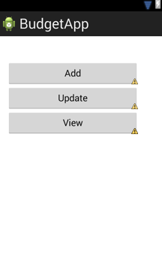

Shopping List (Basic):

